Project 2

Project Performance Analysis

Ngan Le Thi Thai (Crystal)

Northeastern University – College of Professional Study

ALY6010 21420 Probability Theory and Intro Statistics – SEC Winter 2019

Instructor: Dee Chiluiza (PhD.)

3rd March 2019

Introduction

Probability has long been applied commonly in two aspects which are theoretical and experimental. Theoretical probability is referred as “a priori probability - the probability obtained by making an assumption of equal likelihood in the same space” (Hawkins, A., & Kapadia, R, 1984). By contrast, the book mentioned empirical probability as “Frequentist probability - the probability is calculated from observed relative frequencies of different outcomes in repeated trials (Hawkins, A., & Kapadia, R, 1984). From my perspective, the first type is more about assumptions, calculations based on theories while the second method uses the practical trials to test the result. “The two approaches differ, but are not mutually exclusive; rather, they are complementary” (Prodromou, Theodosia, 2012). This project relies on the empirical data and apply probability rules to analyze the performance of projects in the company.

Regarding the project, the raw data is about the projects in a company which evaluated by conditions such as Quality, Speed, Cost. Three criteria are dependent which means each factor has impacts on others to show the performances of projects. Microsoft Excel is used to make calculations and visualizations. The common formula used in this project is COUNTIFS, COUNTIF, basic calculations such as addition, subtraction, multiplication and division.

Analysis

Part 1: Counting and calculating percentage of event Q, S, C.



*(Primary events, notations, number of each event and its percentage)*

In the project, each event Q, S, C represent for the criterion Quality, Speed, Cost respectively. They are defined as P(Q), P(S), P(C). From the table, it can be seen that Speed (44%) is the quality having the most percentage of projects to meet its condition. Overall, projects tend to be on time than meet cost’s and quality’s requirements.



*(Notations with formula)*

The value of each cell in “Count” column is calculated by counting the number of projects having Quality Score more than 600. Then, the percentage of event Q is the number of projects satisfy the condition on total number of projects. Apply this rule to make calculation to other rows in event S and event C.

Part 2: Counting and calculating the probability of projects based on score conditions below:

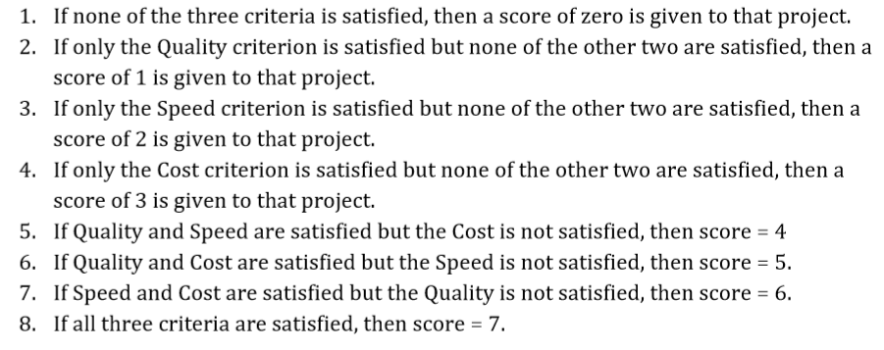

From my perspective, it is easier to start from P (7) because it is the basic condition which can support other events from P (0) to P (6). P (7) is defined as the intersection of Quality, Speech and Cost. In contrast, P (0) including projects do not meet any conditions is the remain region after subtracting other regions (applying Complementary rule). These values can be illustrated visually by Ven Diagram in the next part.

The value of “count” column is made by counting number of projects which meet the conditions of each grade. The percentage of each event is the “count” on the total amount of “count”.

*(Notations with formula of events – break by score)*

The table below illustrate the quantity of projects in each grades and percentage of each grade on total projects of company. In general, 22% of projects has score of 2 which meet the time requirement only. More than 50% of projects have score under or equal to 3. Only 6% of projects meet three given conditions.



Part 3: Ven diagram.

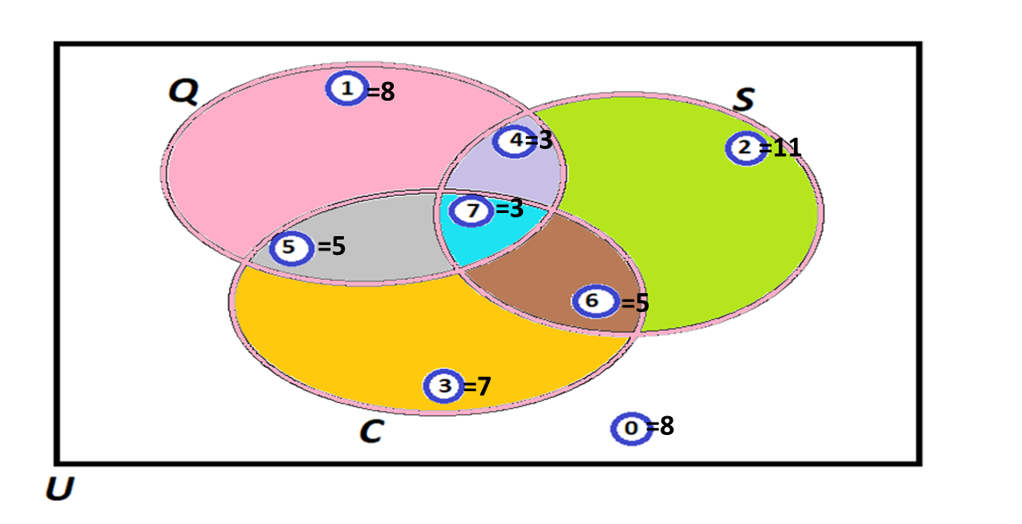*(Number of projects on the score)*

There are eight regions in the Ven diagram which describe eight different scores (from zero to seven) with its quantity. For instance, the pink region is equal to P (1) (score = 1) and there are eight project having score of 1.

Part 4: Counting and Probability for specific questions.



*(Questions with notations)*

There are two different ways to calculate the probability in this case. One way is to use direct number in the previous parts. For instance, to calculate P(Q|S), we can add P (4) and P (7), then divide the sum for P(S). Another way to calculate is counting both numerator and denominator using COUNTIFS.

The formula of later way is illustrated in the below table. In this part, questions are different, then the “count” column describes data of numerators only. The value of denominator will vary on each question.

For the question a) and b) conditional probability is applied to answer the questions.



*(Questions with formula)*



*(Value of calculation)*

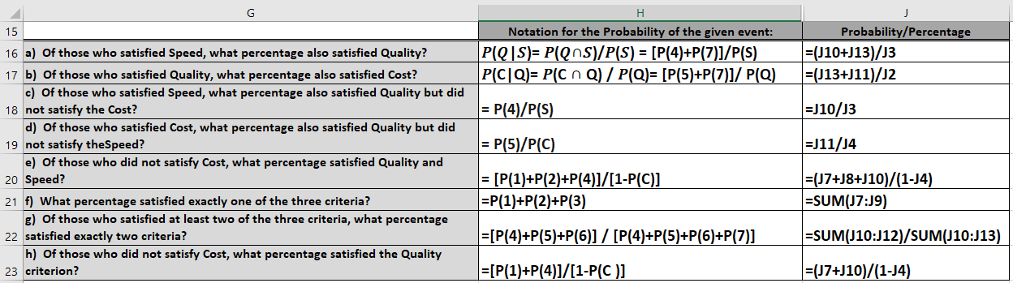

*(Value of calculation)*

I used the direct number in the last parts to calculate probability. I can use COUNTIFS to calculate the probability, but it might cost more time.

Conclusion

In the case study, probability speaks the situation. By asking the questions and set requirements for each grade, these projects are evaluated. It is easier to make comparison between criteria when they are converted to proportion, then recommendations can be made to suitable with the company’s objectives.

The rules of probability are applied and shown in table, Ven diagram using Microsoft Excel. I think it is not too complicated when using almost COUNTIFS formula to calculate. This method is useful for projects relating to assessing performances or projects relating to evaluating numbers. The limit in this analysis is not apply other rules of probability such as The Bayes’ Law. However, the value in cells are calculated to answer these questions.

References

Hawkins, A., & Kapadia, R. (1984). *Children’s conceptions of probability: A psychological and pedagogical review*. Retrieved from <https://link-springer-com.ezproxy.neu.edu/article/10.1007%2FBF00311112>

Prodromou, Theodosia. (2012). *Connecting experimental probability and theoretical probability. ZDM, 44(7), 855-868*. Retrieved from <https://onesearch.library.northeastern.edu/primo-explore/fulldisplay?docid=TN_springer_jour10.1007/s11858-012-0469-z&context=PC&vid=NU&search_scope=default_scope&tab=default_tab&lang=en_US>